**INSTALLATIONS**

* **1. Docker Desktop for Windows**
* **2. WSL installation if needed**
* **3. Account in Docker Hub**
* **4. Minikube (lightweight version of Kubernetes) installation**

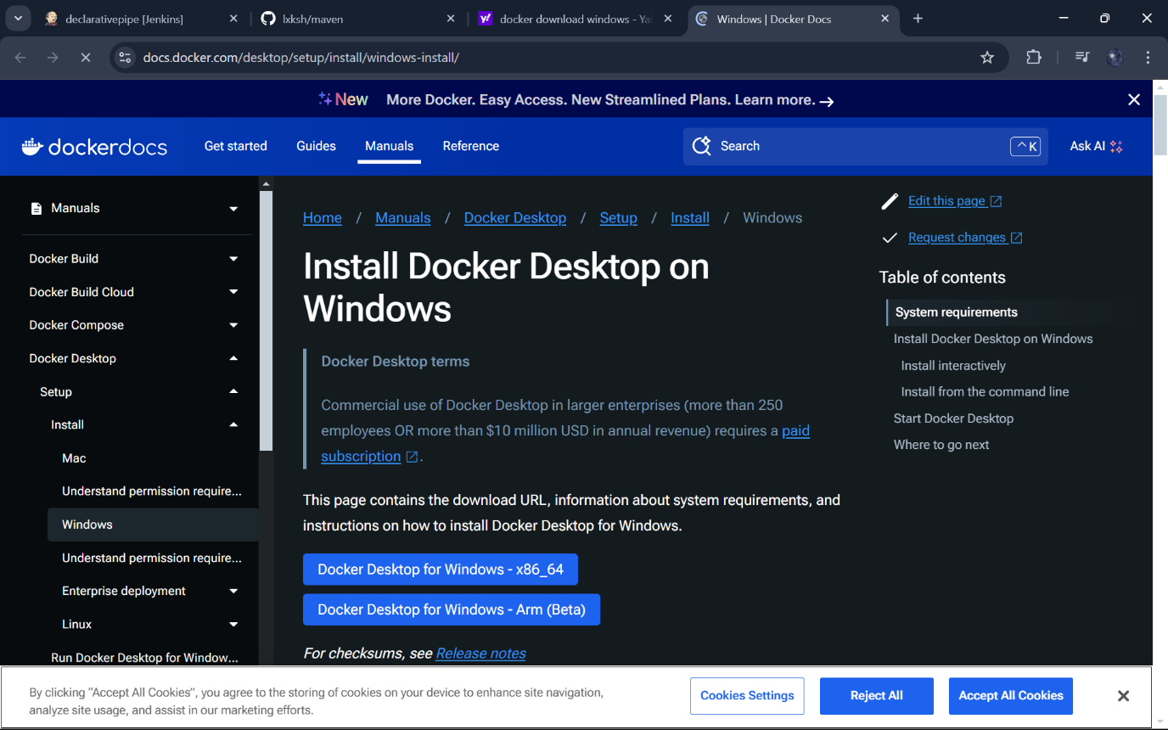Make sure Virtualization is enabled in the system, we can check it in task manager as shown

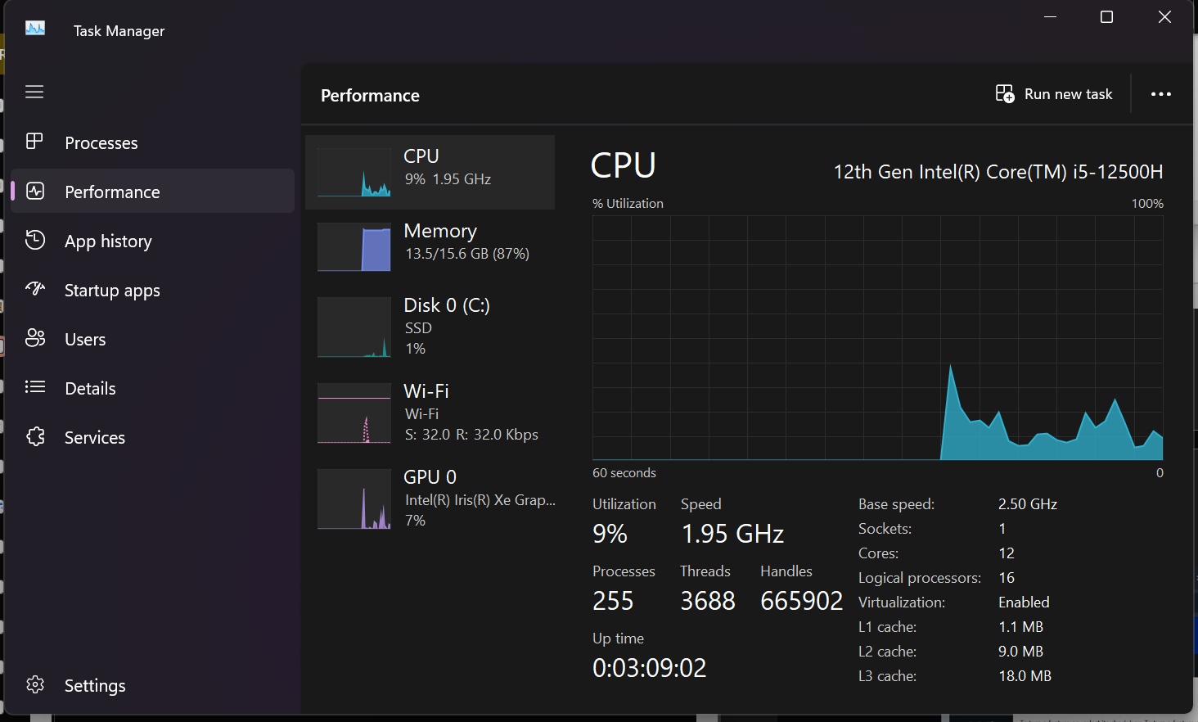Make sure to check the Hyper-V, Virtual Machine Platform, Windows Hypervisor Platform and Windows subsystem for Linux checkboxes and click ok

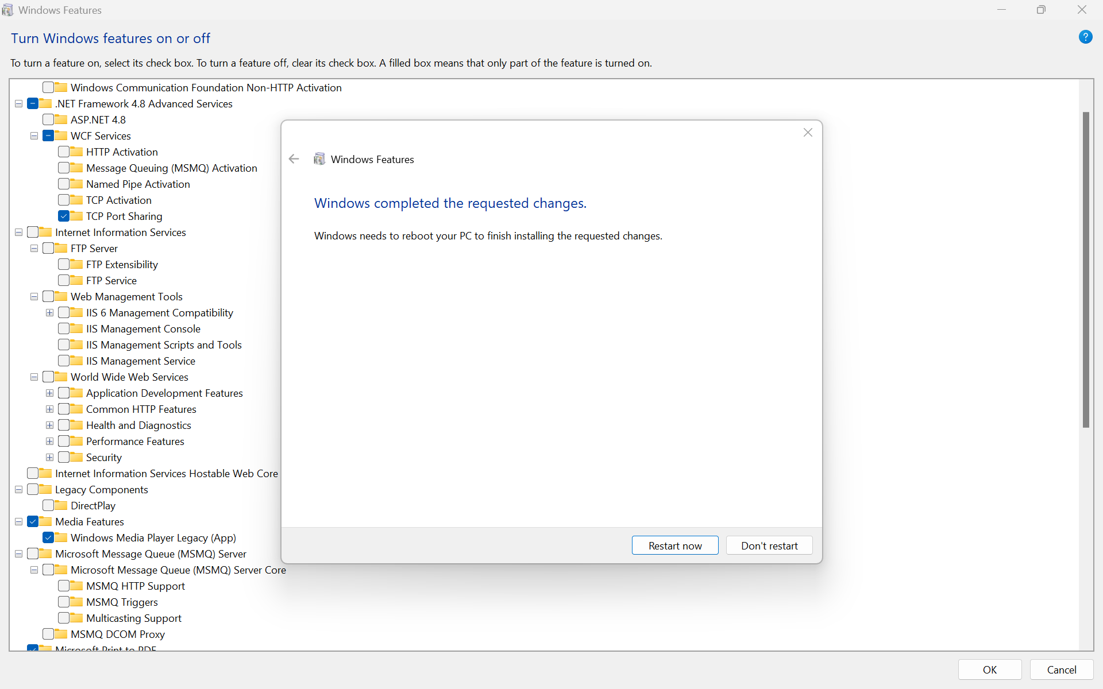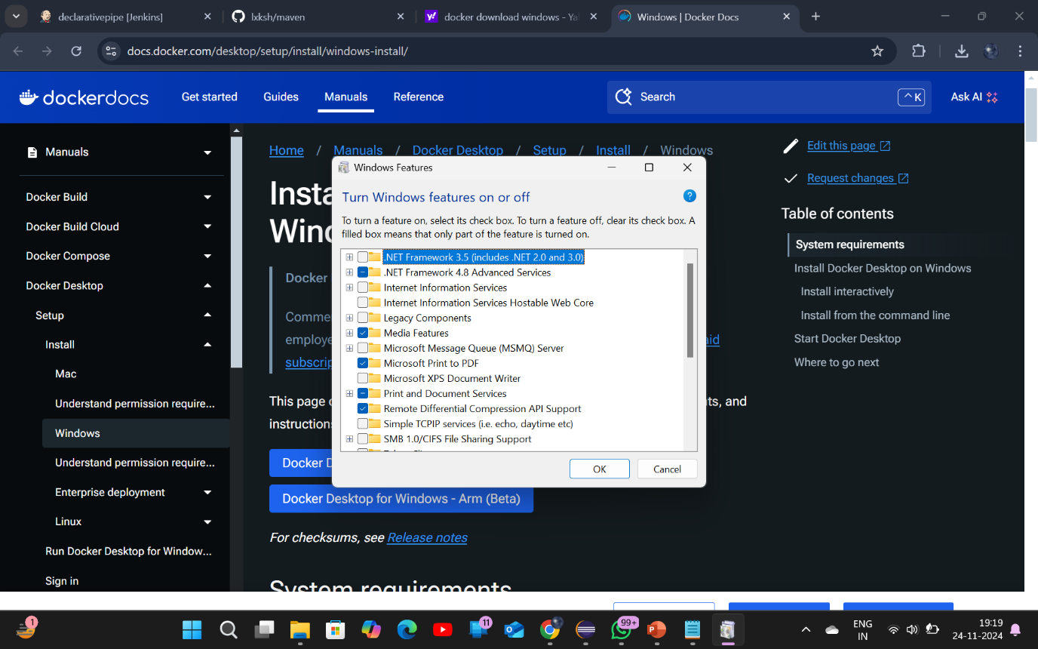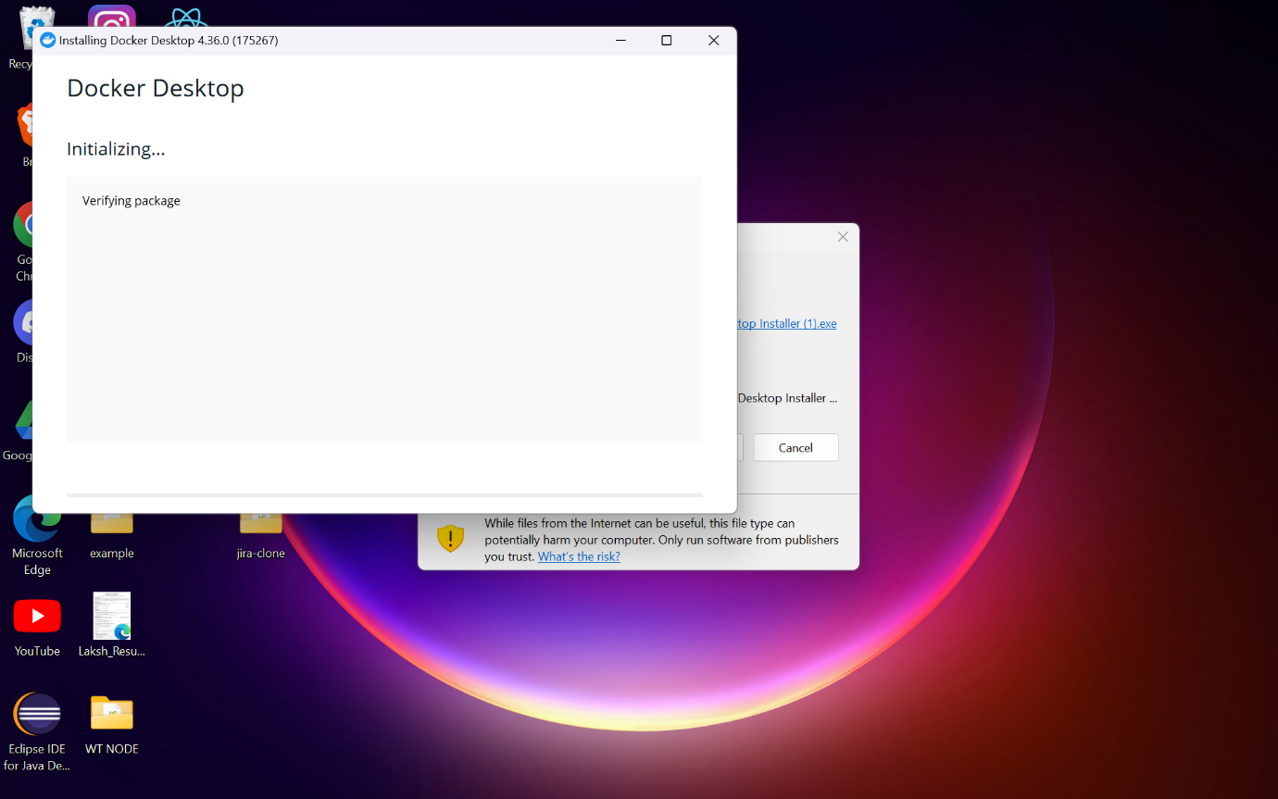Double click the executable file and click ok as shown, make sure the following check boxes are selected

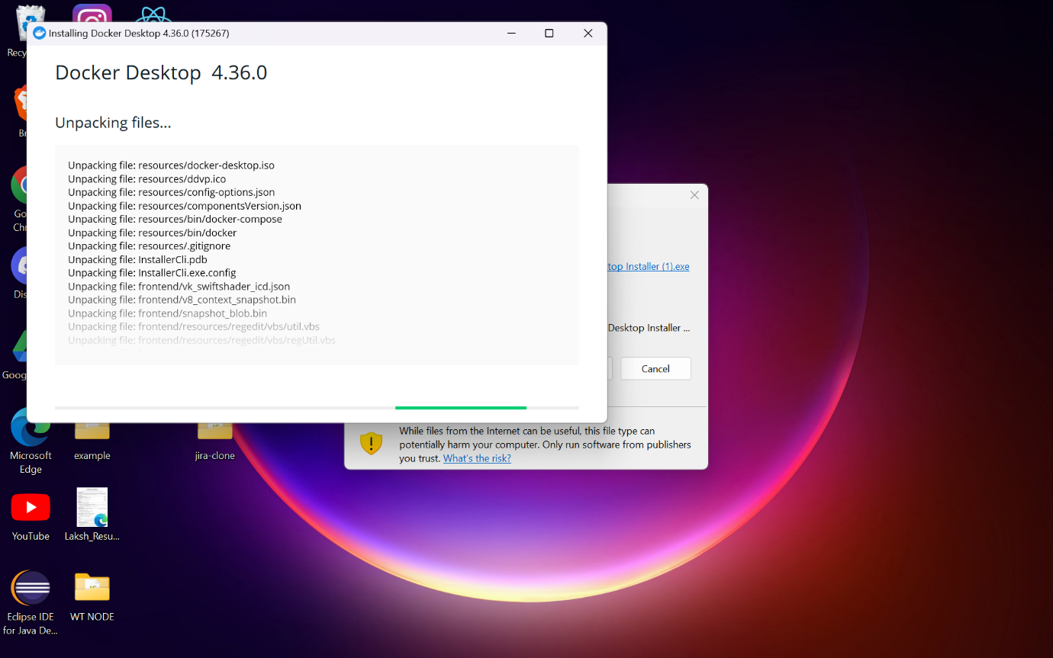Accept the license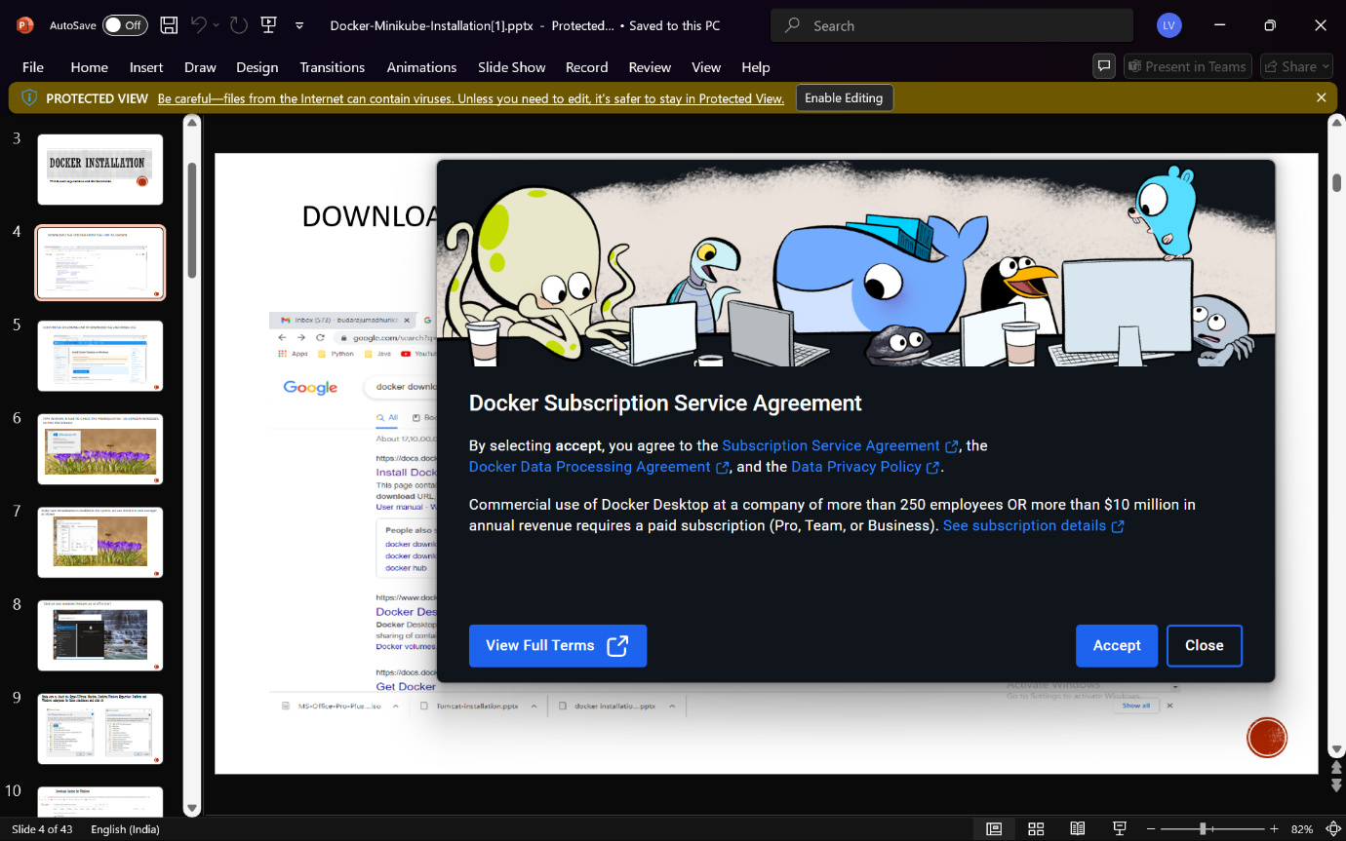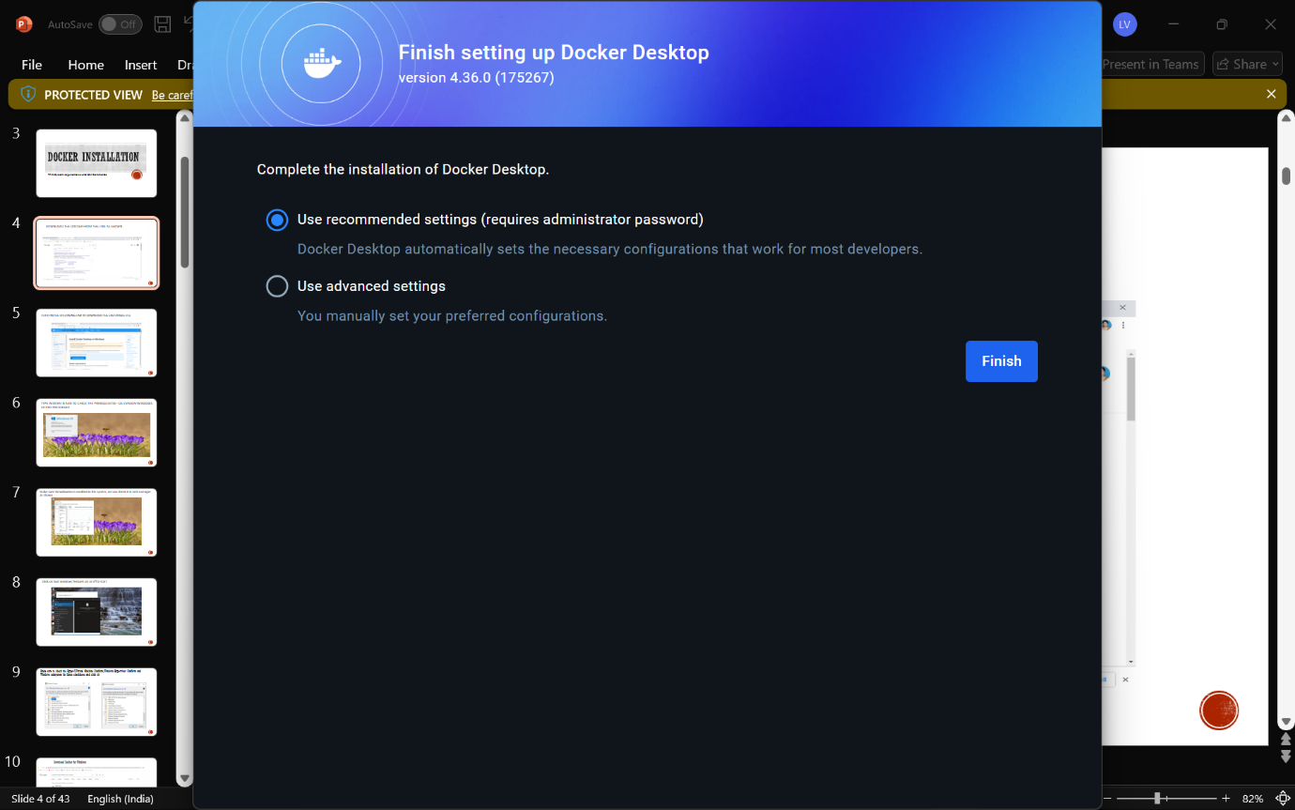

Installation of wsl: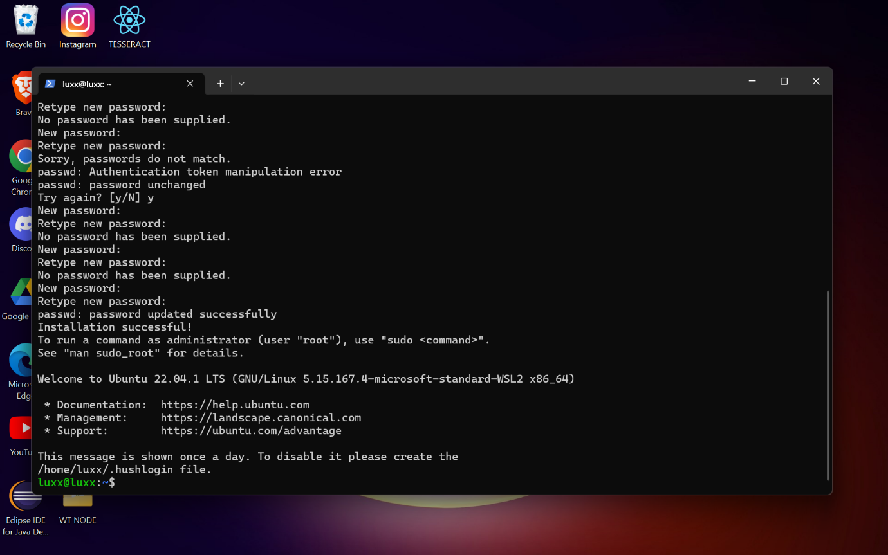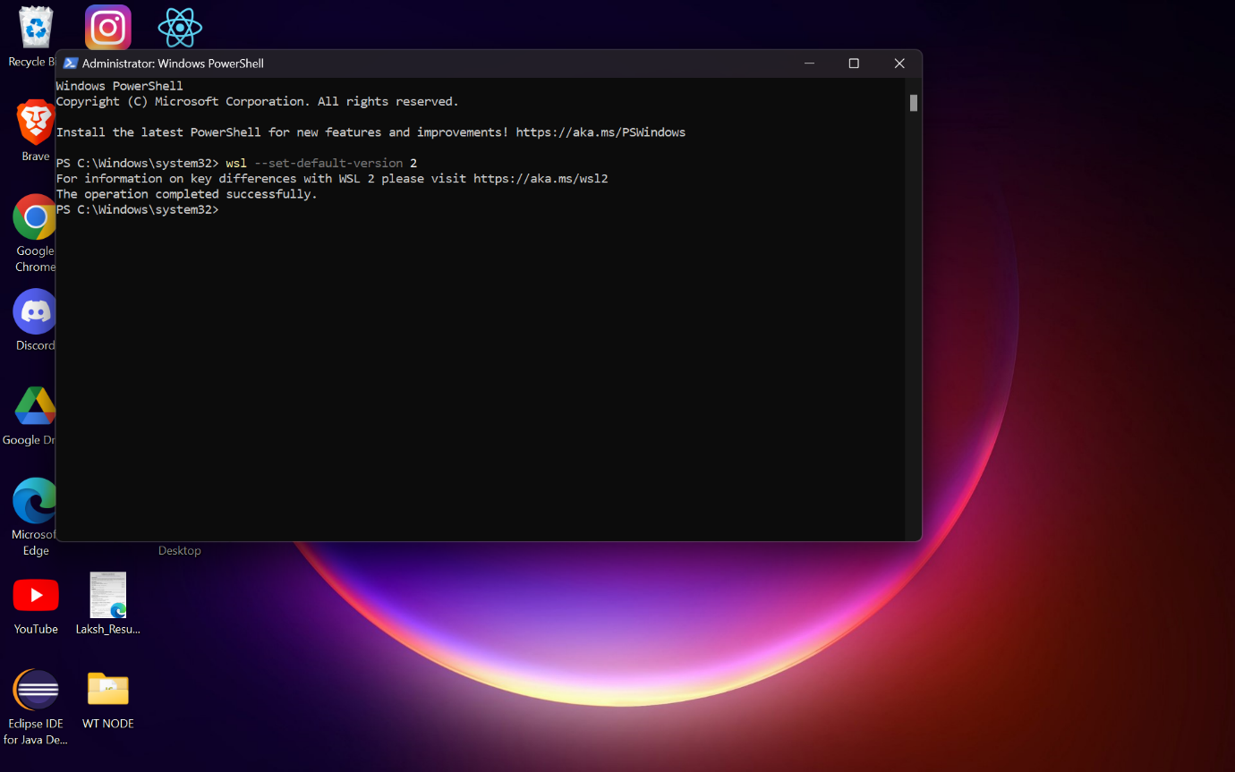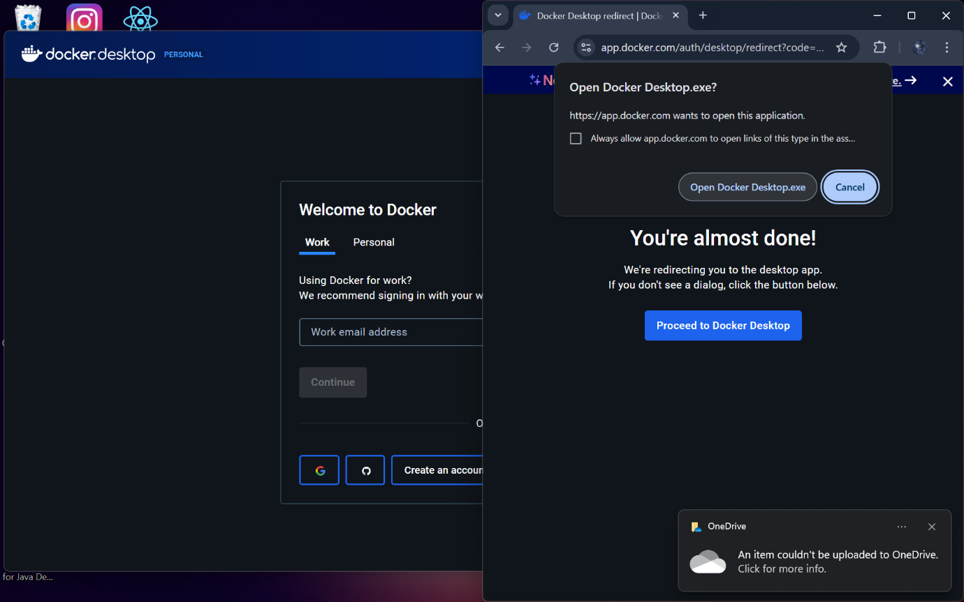Create Docker id and login into docker desktop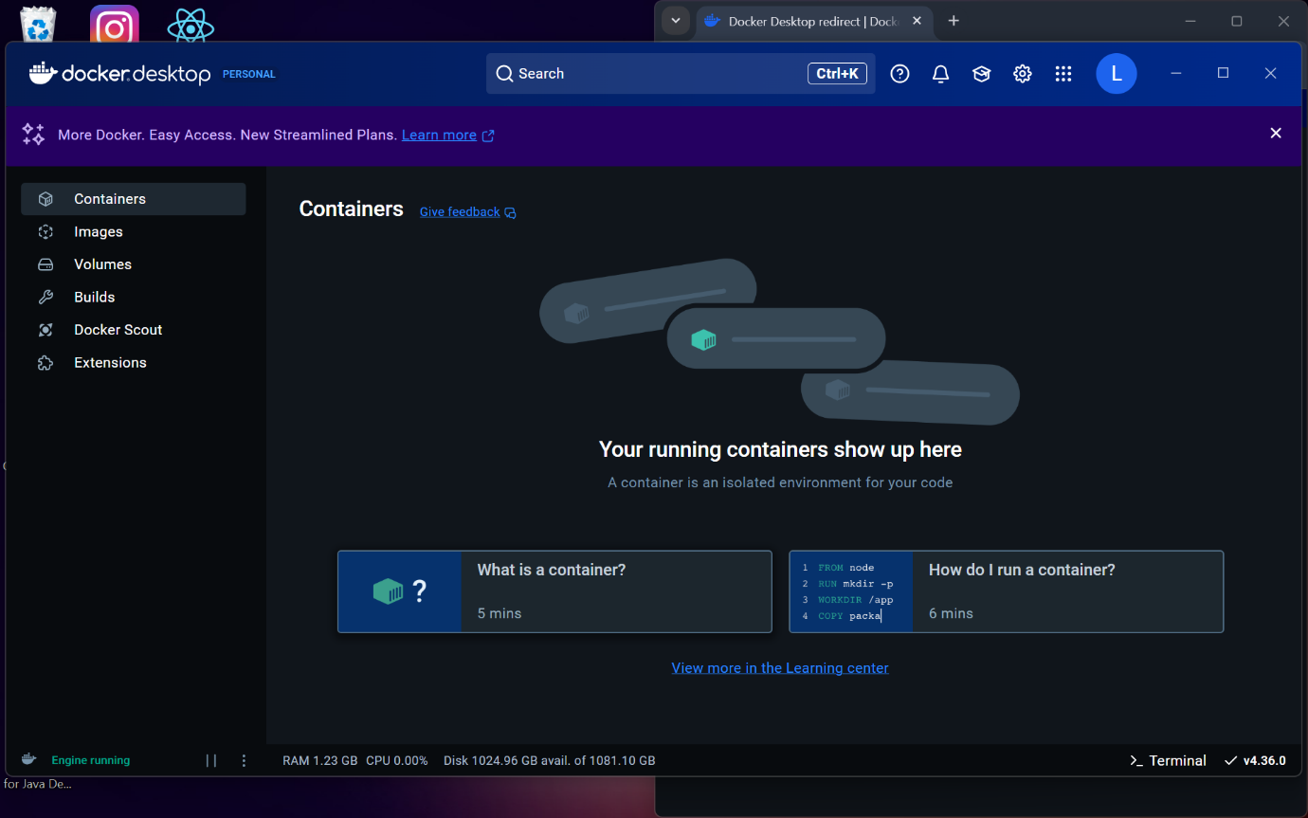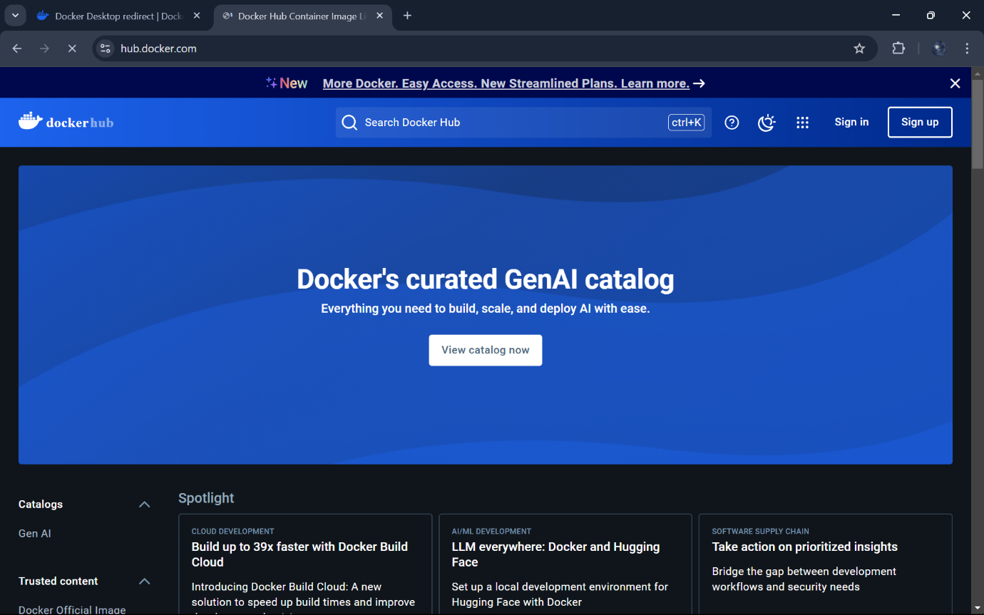Sign up in hub.docker.com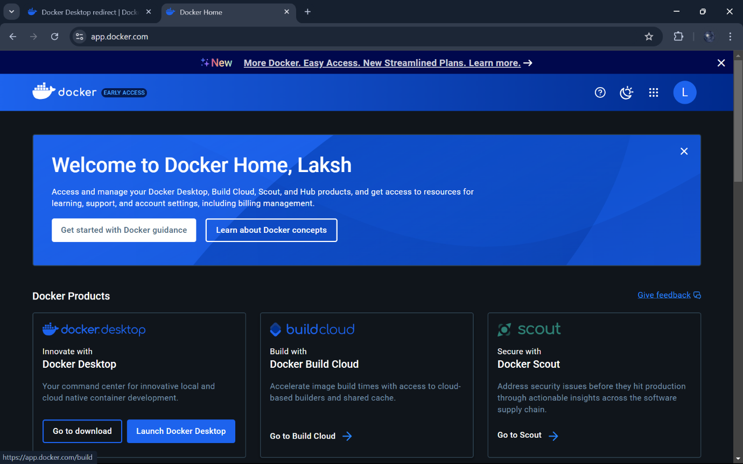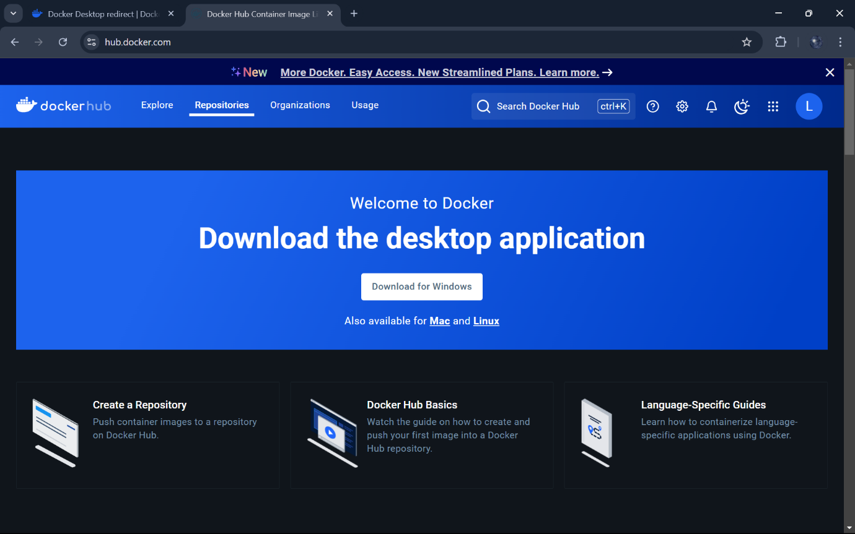

Install using Docker Desktop

Settings 🡪 Kubernetes 🡪 Check Enable Kubernetes 🡪 Apply

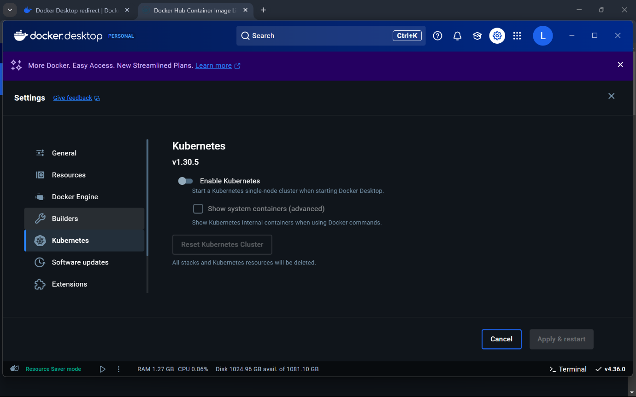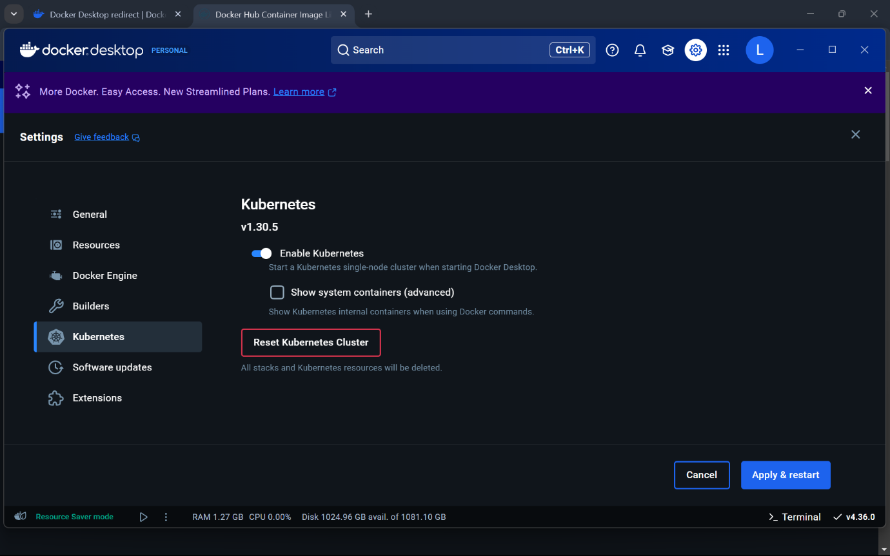[Minikube](https://github.com/kubernetes/minikube) is a tool that allows you to run a single-node Kubernetes cluster inside a virtual machine, on your own computer.

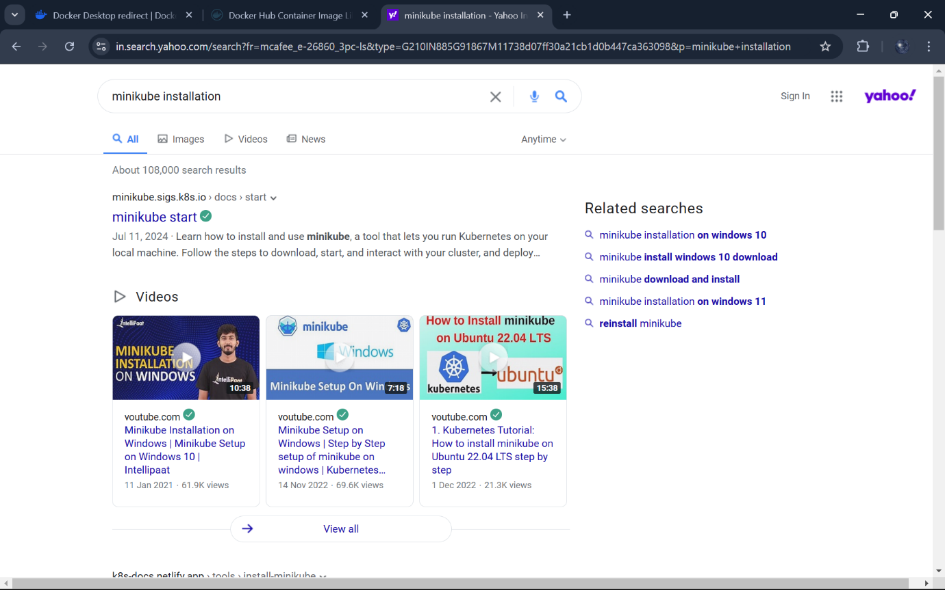Download the required minikube installer for the windows platform.

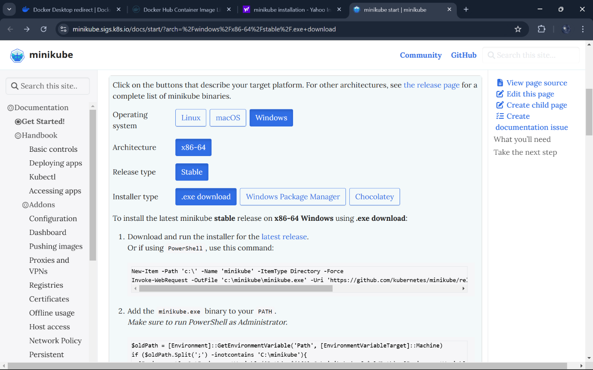Start your cluster by running the following command in powershell

> minikube start [Docker service should be running]

